# Creating your database

You will need to download old versions of WAMPserver and phpBB from the following Sourceforge links:

<http://sourceforge.net/projects/phpbb/files/phpBB%202/>

<http://sourceforge.net/projects/wampserver/files/WampServer%20OutDated/WAMP5/WAMP5%201.7.4/>

1. Install an old version of WAMPserver by downloading and running the executable. Install it somewhere easy to get to: I put mine in C:\wamp
2. Unzip your phpBB folder into \wamp\www\
3. Start your WAMP server. It starts offline by default; do not connect it to the internet! You can do the coursework using localhost.
4. Open your browser of choice, and type ‘localhost’ into the address bar. You should see the WAMPserver home menu.
5. Next, create a MySQL database to use as a backend for your forum.
   1. With your server active, go to <http://localhost/phpmyadmin/>
   2. Click ‘new’ in the sidebar, name the database something appropriate and click ‘create’
6. Next, create a user with admin privilege for your new database.
   1. From phpmyadmin, click ‘users’ -> ‘add user’
   2. Give the user a suitable name and a password (Fill the fields in, do not click ‘generate’ unless you want an automatically generated password.)
   3. Do not give your new user any powers over the database; this comes next. Click ‘create’
   4. From the user menu, click on ‘edit privilege’ for your new user
   5. Scroll to ‘database specific privilege’ and select your phpbb database from the menu
   6. Check the ‘check all’ box and then ‘go’.

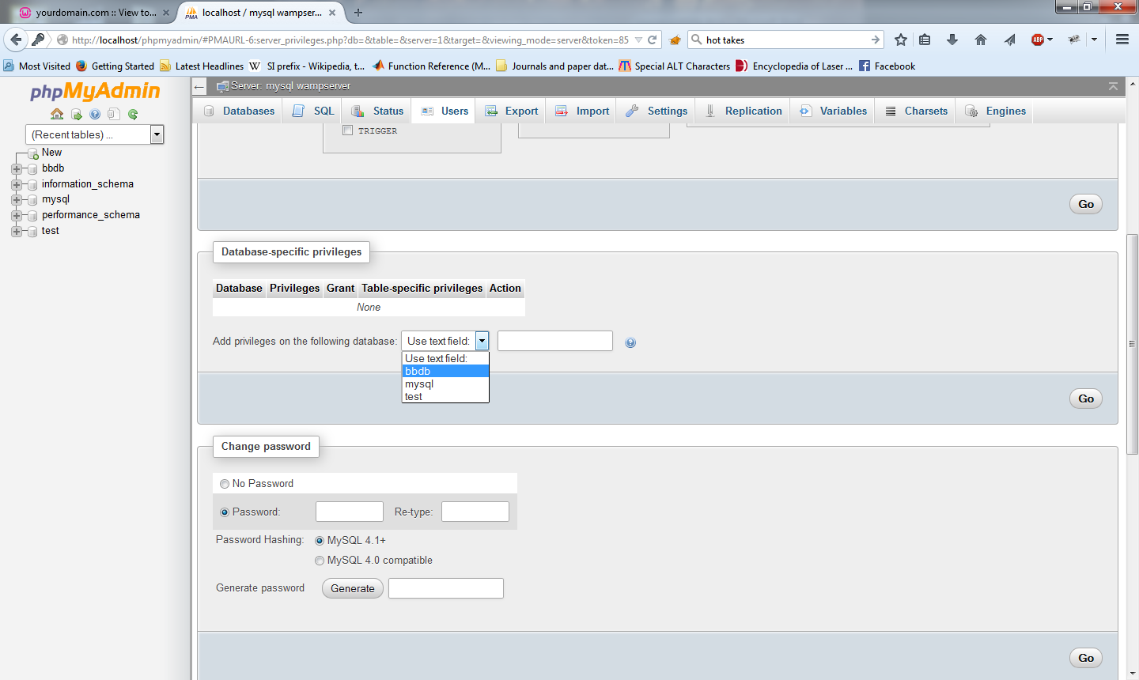

1. Now, install phpBB
   1. Go to the /localhost/phpbb2. You should see an install screen.

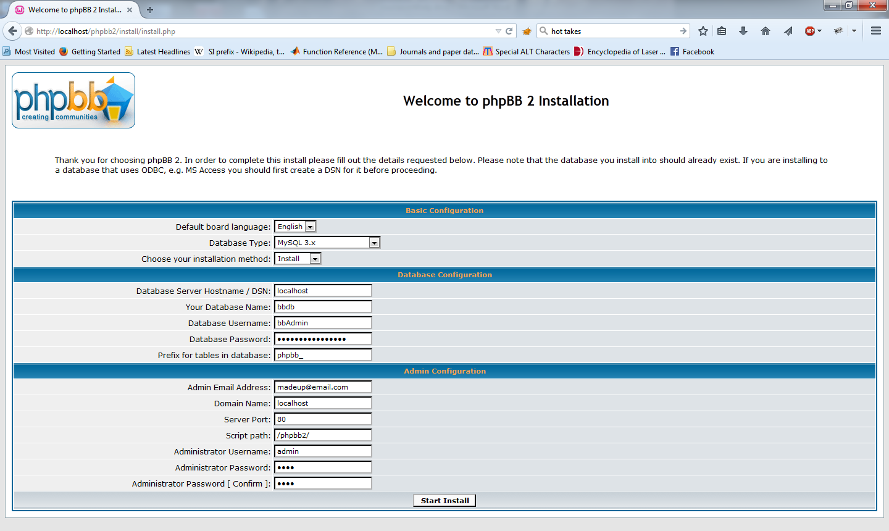

* 1. For ‘your database name’, ‘database username’ and ‘database password’, supply the name, username and password for the database you just created.
  2. Make up an email address, username and password for your admin account.
  3. Make sure you have the correct database type; for the most-downloaded links above, MySQL 4x works.
  4. Click ‘start install’. If all goes well, you should have a functioning forum! Delete the recommended folders if you want.

1. From then on, when your WAMP server is running you can point your browser at ‘http:/localhost/phpbb2/’ and you should see your website.

# Setting up ZAP

For this coursework, you will probably need to inspect and edit HTTP requests sent to your forum. There are many ways of doing this - you could probably write your own if you were so inclined - but I will give you information on setting up ZAP.

You can download ZAP from <https://www.owasp.org/index.php/OWASP_Zed_Attack_Proxy_Project>

Once you have installed ZAP, you have to set it up as a proxy. As both Apache and ZAP use port 8080 by default, you will have to change ZAP’s port; you can do this in tools->options->Local Proxy. I recommend 8081.

Once set up, open your browser find your proxy settings; in Firefox these are under ‘options’->’advanced’->’network’ tab->’settings’ (under ‘connection’). Set the HTTP proxy to ‘localhost’ on the port you chose. This should route all your net traffic through ZAP, where you will be able to see all HTTP requests and responses sent. Make sure to reset your proxy settings when you are done working; alternatively, investigate a custom proxy manager extension for your browser, such as FoxyProxy for Firefox, to allow you to set proxy use by site.